1) Test-Connection confirms whether the destination is reachable (similar to ping).
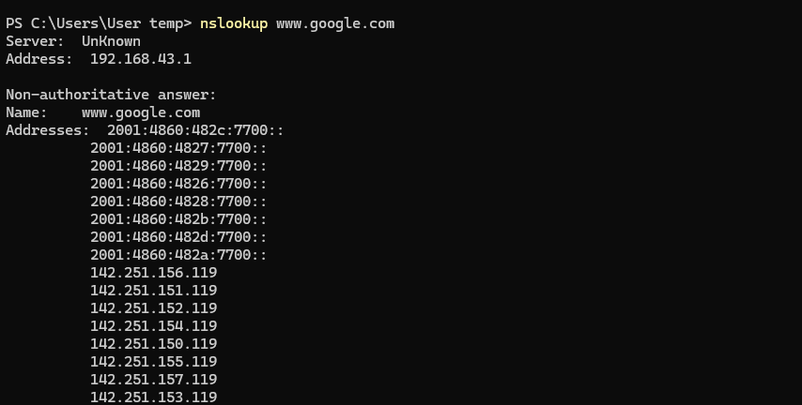
nslookup resolves domain names into IP addresses using DNS servers.

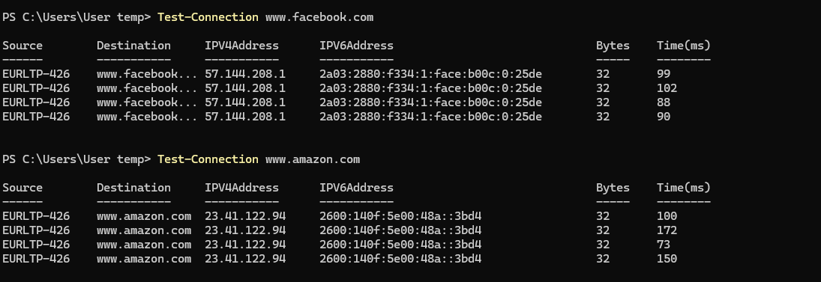
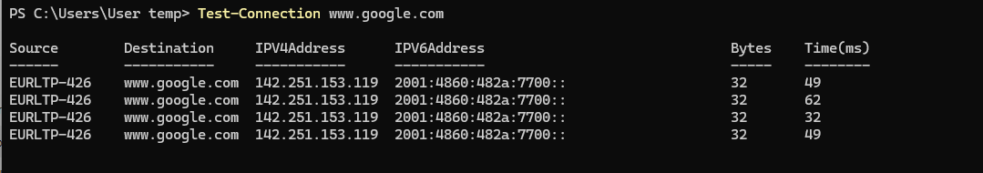
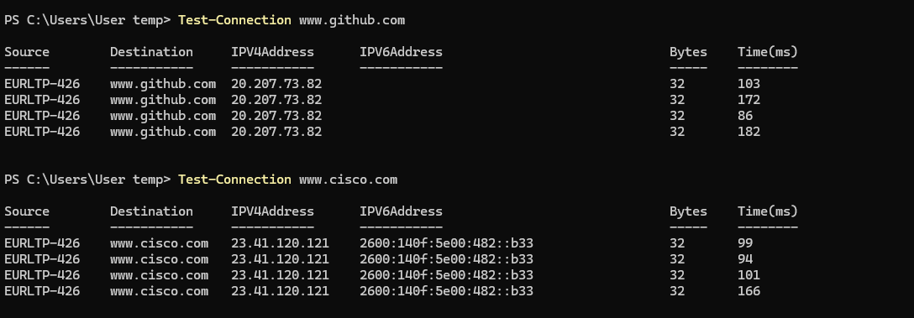
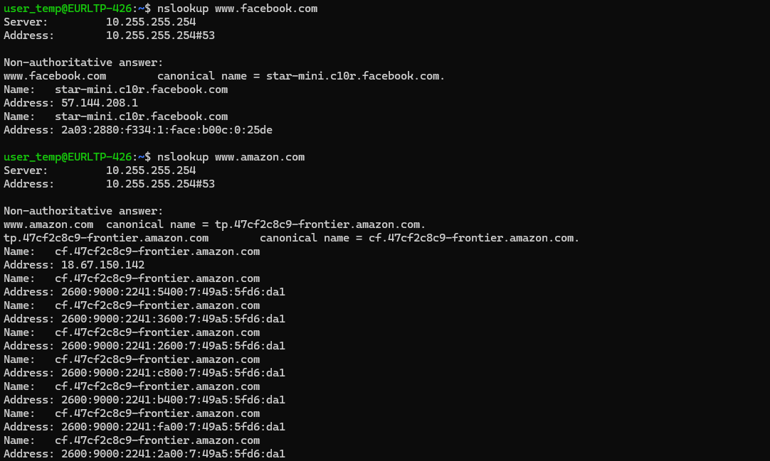

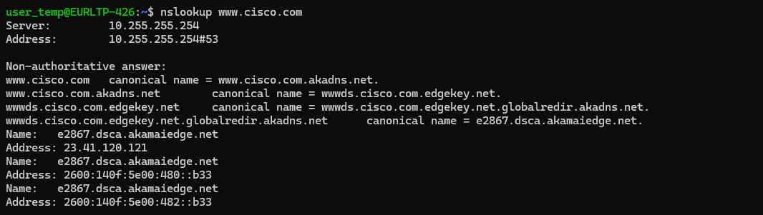

🔹 Observations:
- Test-Connection confirms whether the destination is reachable (similar to ping).
- nslookup resolves domain names into IP addresses using DNS servers.

2) Wireshark Analysis (DNS, TCP, UDP)

Objective:
To capture and analyze network packets.
🔹 Steps:
- Open Wireshark
- Select active network interface
- Start capture
- Apply filters:
  - DNS → dns
  - TCP → tcp
  - UDP → udp
🔹 Observations:
- DNS: Query and response packets
- TCP: 3-way handshake (SYN, SYN-ACK, ACK)
- UDP: Connectionless communication
- Packet headers contain:
  - Source IP
  - Destination IP
  - Protocol
  - Flags

For TCP :
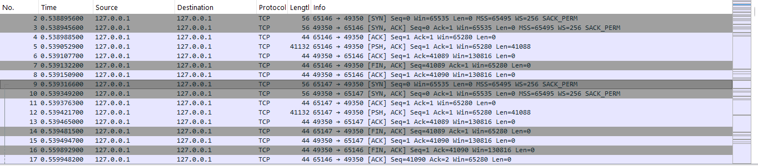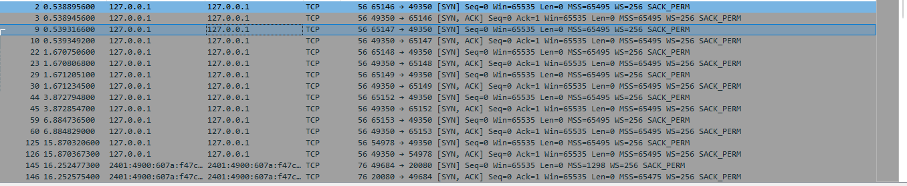

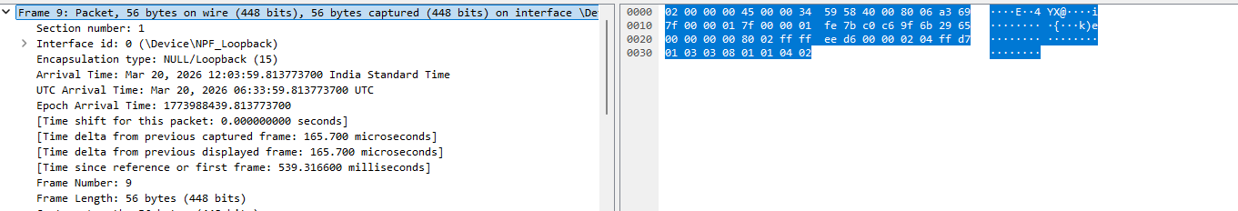

3) Traceroute / Tracert Analysis
Objective:
To track the path taken by packets.
Command:
tracert www.google.com
🔹 Observations:
- Displays intermediate routers (hops)
- Shows latency at each hop
- Helps identify network delays or failures
Output :
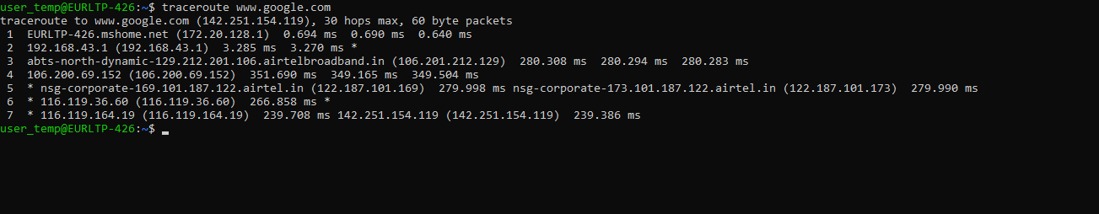
For Google and Facebook

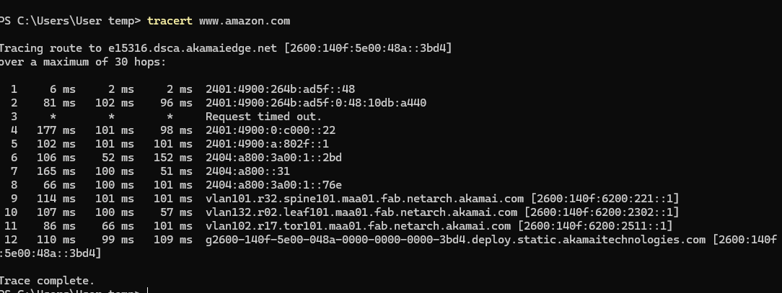
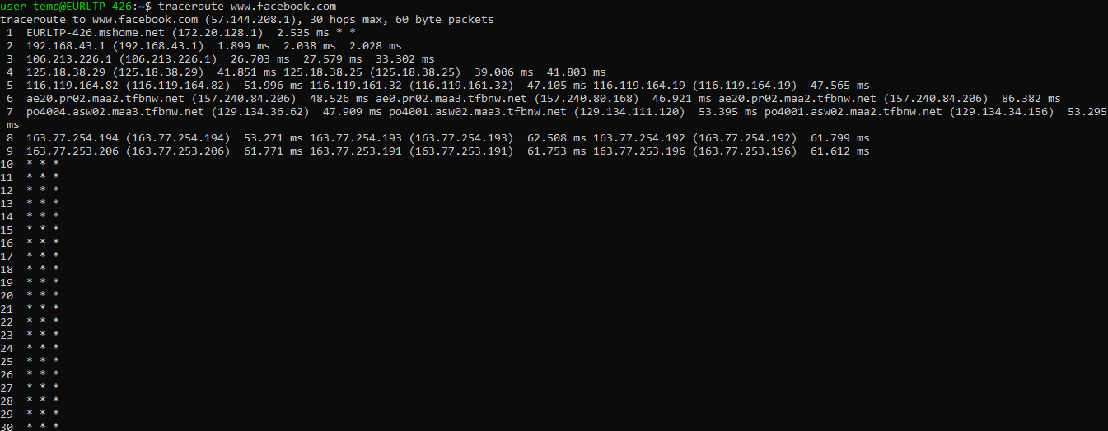

For Linux
Common Options in traceroute (Linux)
1. -n → No DNS resolution
traceroute -n www.google.com
2. -m → Max hops
traceroute -m 15 www.google.com
3. -w → Wait time
traceroute -w 2 www.google.com
4. -q → Number of probes per hop
traceroute -q 3 www.google.com
5. -i → Specify interface
traceroute -i eth0 www.google.com
6. -T → Use TCP instead of UDP
traceroute -T www.google.com

4) Objective:
To simulate a network environment.
Steps:
- Open Cisco Packet Tracer
- Add:
  - 2 PCs
  - 1 Switch
- Connect using straight-through cable
- Assign IP addresses
- Test using ping
Result:
- Successful communication between PCs

Output:
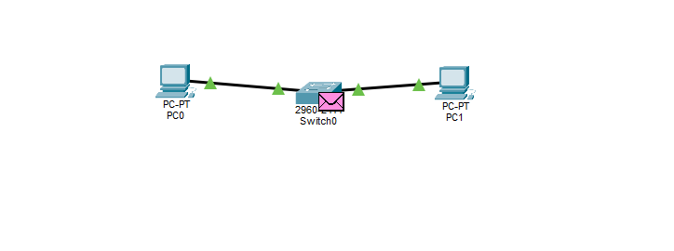

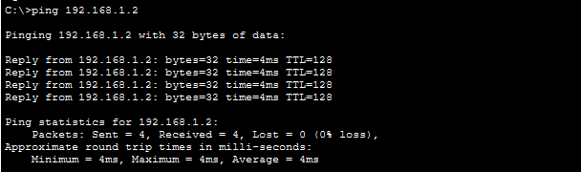

7. Configure Management VLAN with Remote Access (SSH/Telnet)
Steps:
- Create VLAN:
Switch(config)# vlan 99
Switch(config-vlan)# name Management
- Assign IP to VLAN interface:
Switch(config)# interface vlan 99
Switch(config-if)# ip address 192.168.99.1 255.255.255.0
Switch(config-if)# no shutdown
- Configure default gateway:
Switch(config)# ip default-gateway 192.168.99.254

4a) Telnet:
Switch(config)# line vty 0 4
Switch(config-line)# password 1234
Switch(config-line)# login
Testing
Use : telnet ip
4b) Enable SSH:
Switch(config)# hostname Switch
Switch(config)# ip domain-name lab.com
Switch(config)# crypto key generate rsa
Switch(config)# username admin password 1234
Switch(config)# line vty 0 4
Switch(config-line)# login local
Switch(config-line)# transport input ssh telnet
Testing:
- Use: ssh admin@192.168.99.1
Outputs :

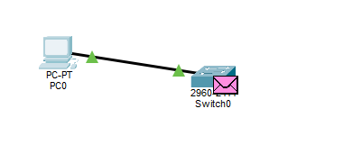

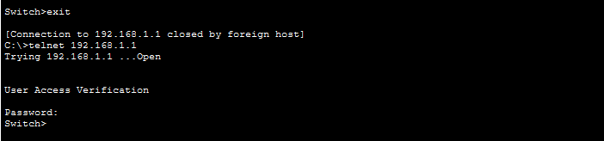

Q8 – Voice VLAN (20) & Data VLAN (10)
Step 1: Enter Configuration Mode
Switch> enable
Switch# configure terminal

Step 2: Create VLAN 10 (Data)
Switch(config)# vlan 10
Switch(config-vlan)# name DATA
Switch(config-vlan)# exit

Step 3: Create VLAN 20 (Voice)
Switch(config)# vlan 20
Switch(config-vlan)# name VOICE
Switch(config-vlan)# exit

Step 4: Configure Switch Port
Switch(config)# interface fa0/1
Switch(config-if)# switchport mode access
Switch(config-if)# switchport access vlan 10
Switch(config-if)# switchport voice vlan 20
Switch(config-if)# no shutdown

Step 5: Connect Devices
- Connect Switch Fa0/1 → IP Phone
- Connect PC → IP Phone (PC port)

Step 6: Configure IP Address
- PC → IP from VLAN 10 network (e.g., 192.168.10.1)
- IP Phone → IP from VLAN 20 network (via DHCP or manual)

Step 7: Verify Configuration

Switch# show vlan brief
Switch# show interfaces fa0/1 switchport

Step 8: Result
- PC traffic → VLAN 10
- IP Phone traffic → VLAN 20
- Both work on same port successfully
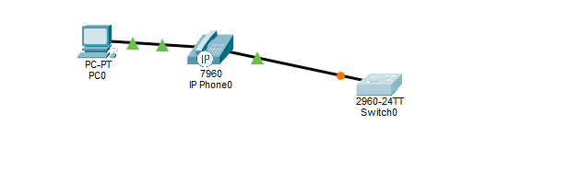
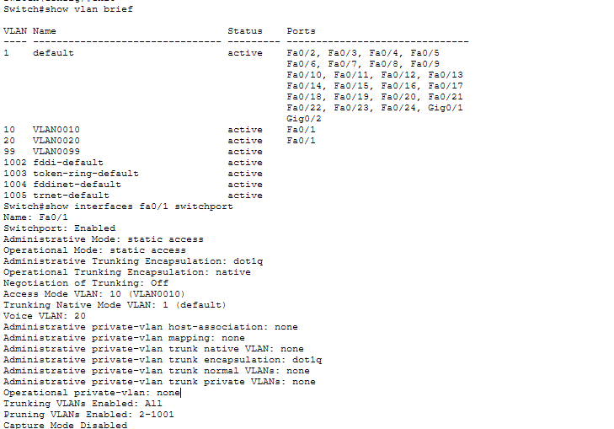

9. VLAN 10 cannot communicate with VLAN 20 (Troubleshooting)
Reason:
- VLANs are isolated (no inter-VLAN routing)
Solution:
- Configure router or Layer 3 switch
- Enable inter-VLAN routing
Example (Router-on-a-Stick):
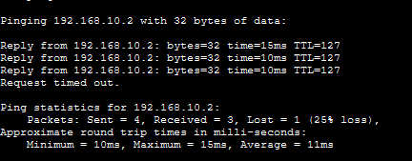
Router(config)# interface g0/0.10
Router(config-subif)# encapsulation dot1Q 10
Router(config-subif)# ip address 192.168.10.1 255.255.255.0
Router(config)# interface g0/0.20
Router(config-subif)# encapsulation dot1Q 20
Router(config-subif)# ip address 192.168.20.1 255.255.255.0

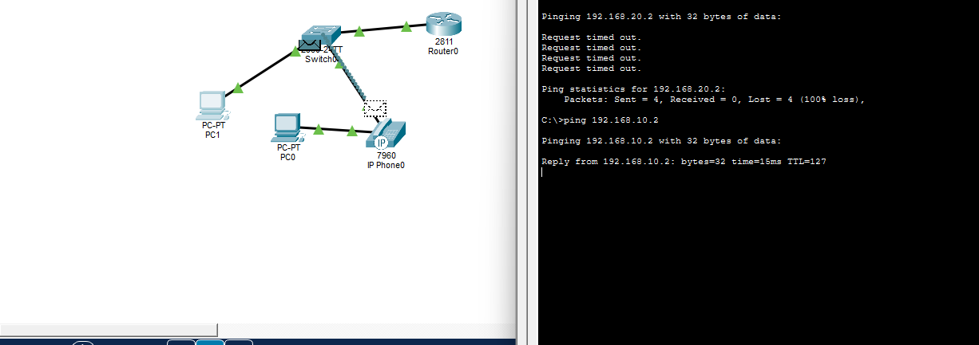

10) Inter- Vlan communication
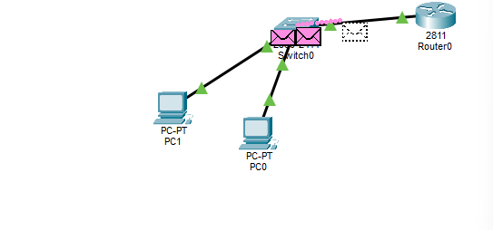

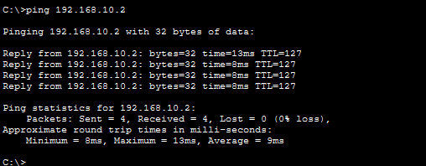

11) Implementation of Extended Access Control List
Step 1: Enter Privileged and Global Configuration Mode
Access the router CLI and enter privileged mode, followed by global configuration mode using:
- enable
- configure terminal

Step 2: Create an Extended Access Control List
Define an extended ACL to control traffic based on protocol and port number.
- Permit HTTP traffic (port 80):
  - access-list 101 permit tcp any any eq 80
- Deny all other traffic:
  - access-list 101 deny ip any any

Step 3: Apply the ACL to an Interface
Apply the ACL to the appropriate interface using the ip access-group command.
- In a router-on-a-stick configuration, apply it on the subinterface:
  - interface fa0/0.10
  - ip access-group 101 in

Step 4: Verify the ACL Configuration
Use verification commands to check whether the ACL is configured and active:
- show access-lists

Step 5: Test the Configuration
- Attempt to send ICMP (ping) packets between devices. These should be blocked.
- Attempt HTTP communication (if a server is present). This should be allowed.
OUTPUT:
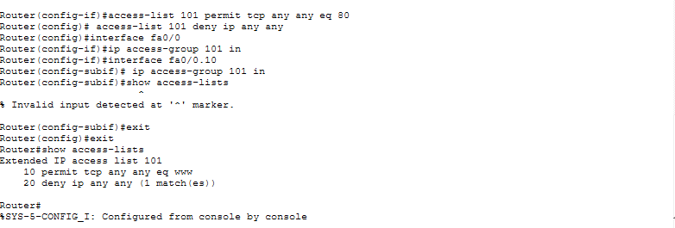
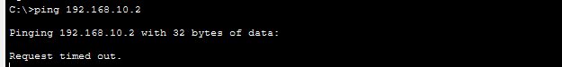

12. Configure a Standard Access Control List (ACL)
Objective:
Allow traffic only from a specific IP range and deny all others.
Steps:
- Enter Privileged Mode
Router> enable
- Enter Global Configuration Mode
Router# configure terminal
- Create a Standard ACL
- Example: Permit network 192.168.1.0/24
Router(config)# access-list 10 permit 192.168.1.0 0.0.0.255
- Apply ACL to Interface
- Apply inbound on interface (e.g., FastEthernet0/0)
Router(config)# interface fa0/0
Router(config-if)# ip access-group 10 in
- Exit Configuration Mode
Router(config-if)# exit
Router(config)# exit
Testing:
- Test Connectivity
- From allowed IP → Should work
- From other IP → Should be blocked
- Verify ACL
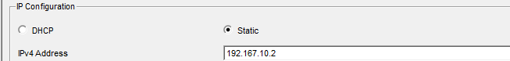
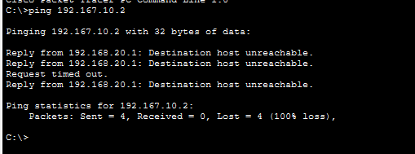
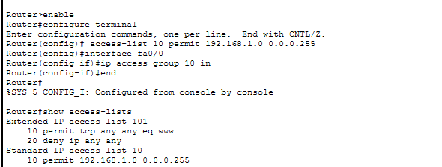
Router# show access-lists

13. Configure an Extended ACL (Block HTTP/FTP Traffic)
Objective:
Block specific applications like HTTP (port 80) and FTP (port 21).
Steps:
- Enter Configuration Mode
Router# configure terminal
- Create Extended ACL
Router(config)# access-list 101 deny tcp any any eq 80
Router(config)# access-list 101 deny tcp any any eq 21
Router(config)# access-list 101 permit ip any any
- Apply ACL to Interface
Router(config)# interface fa0/0
Router(config-if)# ip access-group 101 in
- Exit
Router(config-if)# exit
Router(config)# exit
Testing:
- Test HTTP/FTP Access
- Open website → Should fail
- Other traffic (ping, etc.) → Should work
- Verify
Router# show access-lists
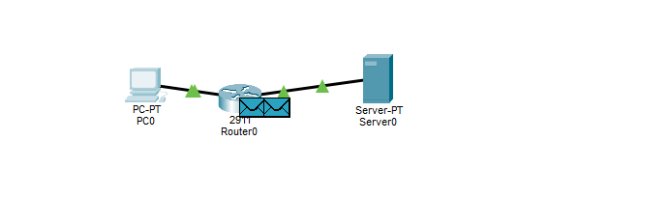
Outputs :

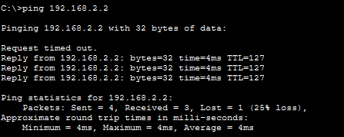

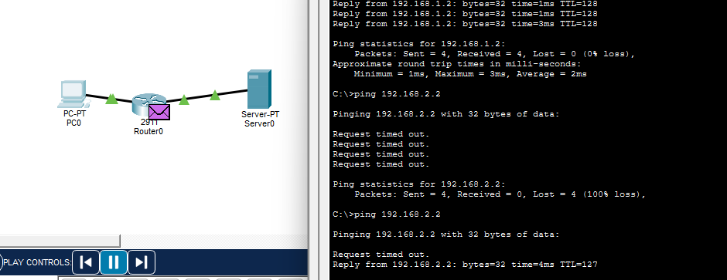

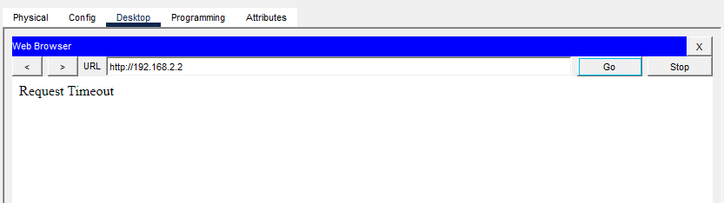
14. Configure NAT (Static, Dynamic, PAT)

A. Static NAT
Objective:
Map one private IP to one public IP.
Steps:
- Define inside and outside interfaces:
Router(config)# interface fa0/0
Router(config-if)# ip nat inside
Router(config)# interface fa0/1
Router(config-if)# ip nat outside
- Configure static mapping:
Router(config)# ip nat inside source static 192.168.1.2 200.1.1.2
- Verify:
Router# show ip nat translations

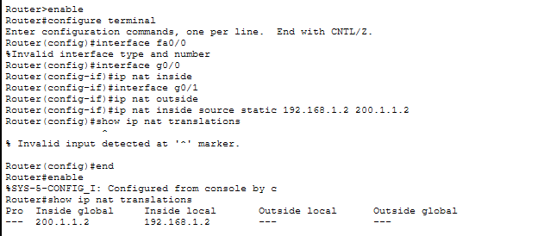

B. Dynamic NAT
Objective:
Map private IPs to a pool of public IPs.
Steps:
- Create ACL:
Router(config)# access-list 1 permit 192.168.1.0 0.0.0.255
- Define NAT pool:
Router(config)# ip nat pool MYPOOL 200.1.1.1 200.1.1.10 netmask 255.255.255.0
- Bind ACL to pool:
Router(config)# ip nat inside source list 1 pool MYPOOL
- Verify:
Router# show ip nat translations

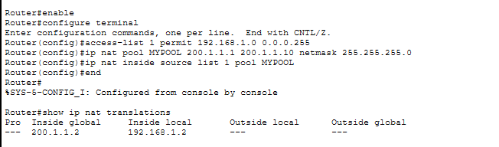

C. PAT (Port Address Translation)
Objective:
Multiple devices share one public IP.
Steps:
- Create ACL:
Router(config)# access-list 1 permit 192.168.1.0 0.0.0.255
- Enable PAT:
Router(config)# ip nat inside source list 1 interface fa0/1 overload
- Verify:
Router# show ip nat translations


15. Network Performance Analysis using iPerf (Linux)
Objective:
To measure network performance parameters such as bandwidth, jitter, delay, and packet loss using the iPerf tool in a Linux environment.

Procedure:
Step 1: Install iPerf3
Open terminal and install iPerf3 using:
sudo apt update
sudo apt install iperf3 -y

Step 2: Start iPerf Server
In the first terminal, run:
iperf3 -s
This system acts as the server.

Step 3: Run iPerf Client
In another terminal, execute:
iperf3 -c 127.0.0.1
This connects the client to the server using localhost.

Step 4: Perform Different Tests
1. TCP Test
iperf3 -c 127.0.0.1
- Measures bandwidth and throughput
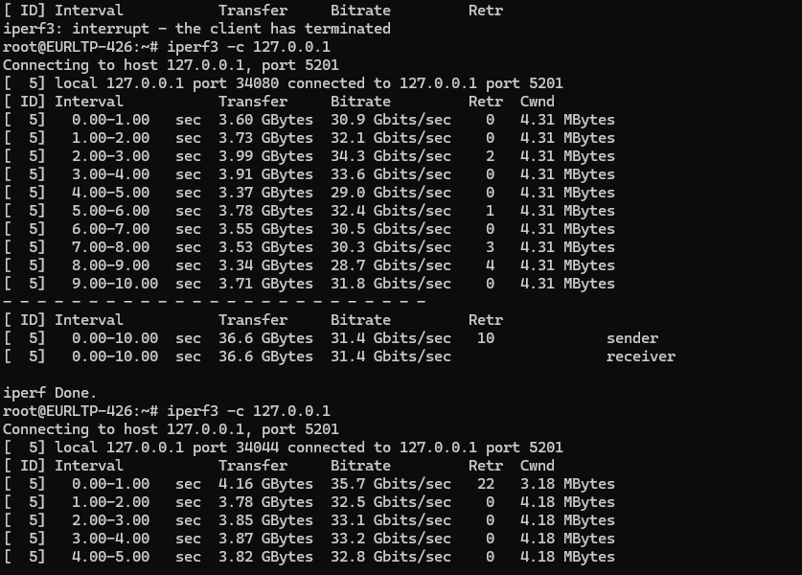

2. UDP Test
iperf3 -c 127.0.0.1 -u
- Measures jitter and packet loss
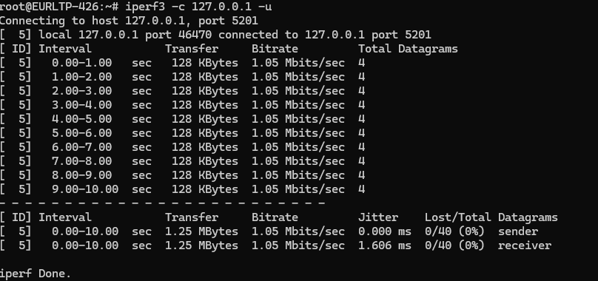

3. Reverse Mode
iperf3 -c 127.0.0.1 -R
- Tests data transfer from server to client
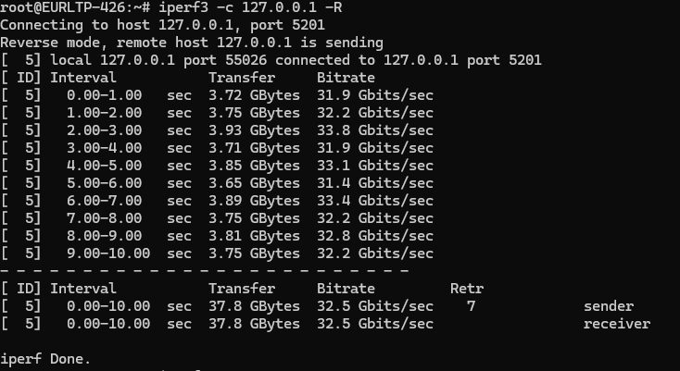

4. Parallel Streams
iperf3 -c 127.0.0.1 -P 5
- Simulates multiple simultaneous connections
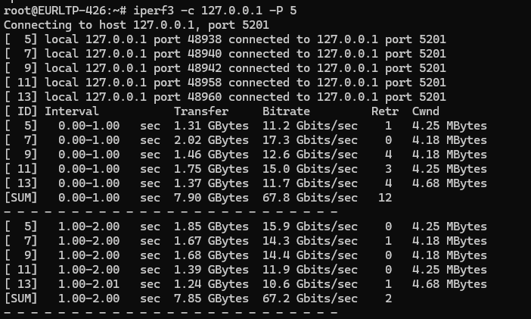

5. Bidirectional Test
iperf3 -c 127.0.0.1 --bidir
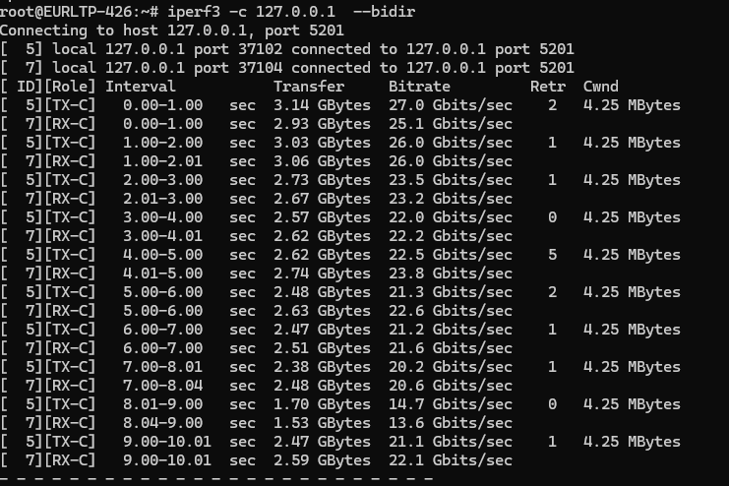
- Tests simultaneous two-way communication

Observations:
- High bandwidth values were observed during TCP testing.
- UDP test showed low jitter and zero packet loss.
- Parallel streams increased overall throughput.
- Bidirectional mode confirmed simultaneous data transmission.
.

